CC Alg I : Midyear Review Part 1A Name: _______________________

Cumulative Review for Semester 1 Date: _______________ Pd: _____

**I. Multiple Choice**

*Choose the best answer for each of the follow. Please put the letter that corresponds to your answer on the line provided.*

1. Which of the following could be represented by a linear function?

Score

Part 1: _______

Part 2: _______

Total: _______

|  |  |
| --- | --- |
| $$x$$ | $$g(x)$$ |
| -2 | 2 |
| 0 | 0 |
| 1 | 1 |
| 2 | 2 |
| 4 | 4 |

1. 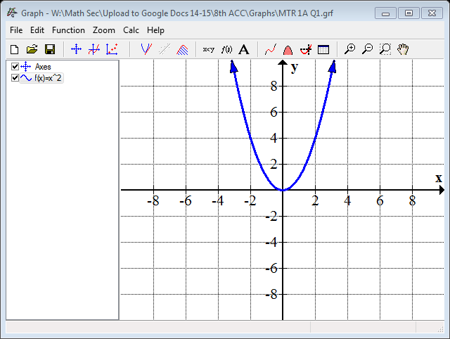 C.
2. $\{\left(-3, -2\right),\left(-2, 0\right), \left(0,4\right), \left(2,8\right),\left(3,10\right)\}$ D. $32, 16, 8, 4, 2…$
3. The Big Theater sold tickets for their children’s production next month. Adult tickets are $7 and child tickets are $4. If they sold a total of 460 tickets, and made a total of $2455, how many of each type were sold?
4. 255 adult, 205 student
5. 205 adult, 255 student
6. 160 adult, 300 student
7. 300 adult, 160 student
8. Which of the following systems yields a no solution? (Choose all that apply)
9. $2x+2y=2$ C. $y=5x+6$

$4x+4y=4$ $y=5x-4$

1. $2x-y=10$ D. $5x-4y=12$

$y=2x -12$ $-6x+12y=10$

1. The formula for the surface area, $S$, of a pyramid, is $S= \frac{1}{2}Pl+B$, where $P$ is the of the base, $l$ is the slant height, and $B$ is the area of the base. Which of the following expresses this relationship in terms of slant height?
2. $l=\frac{2S-B}{P}$ C. $l=\frac{2S}{P}-B$
3. $l=2SP-B$ D. $l=\frac{2\left(S-B\right)}{P}$
4. What is the solution to the following inequality; $11x-36<20x+72$
$x>-12$

$x<-12$

$x>4$

$x< 4$

5. What is the value of $f(-5)$, when $f\left(x\right)=47-3x^{2}$
6. -178
7. -28
8. 62
9. 122
10. Below the boundary lines for the system of inequalities has been graphed.

$$\left\{\begin{aligned}y≥3x-5 \\ 2x-4y<-10\end{aligned}\right.$$

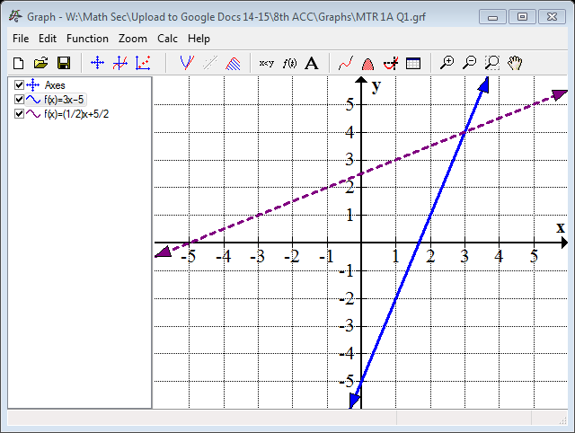

Which point is a solution to the system of inequalities?

1. (0, 0)
2. (-2, 4)
3. (3, -3)
4. (4, 5)
5. Comparing the two functions below, $f(x)$ and $g(x)$, which of the following comparisons is true?

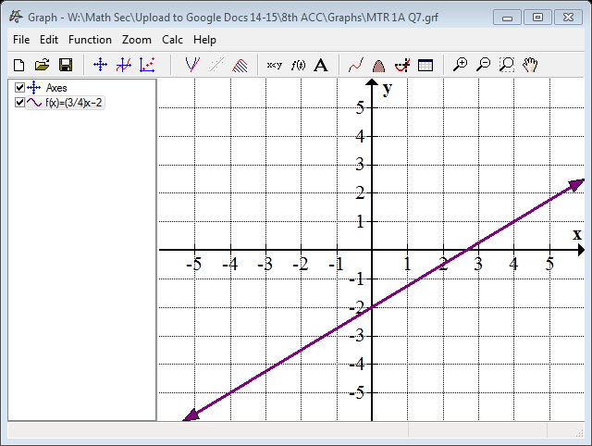

|  |  |
| --- | --- |
|  |  |
| -5 | 2 |
| 0 | 1 |
| 5 | 0 |
| 10 | -1 |

1. The rate of change of both functions is negative.
2. The rate of change of both functions is positive.
3. The rate of change of $f(x)$ is greater than the rate of change of $g(x)$.
4. The rate of change of $g(x)$ is greater than the rate of change of $f\left(x\right).$
5. Which of the following shows both correlation and causation? Choose all that apply.
6. As a person’s workout gets more intense, their body temperature rises
7. As a person saves more data onto a hard drive, the remaining space on the hard drive decreases
8. As the volume of the music increases, the number of people attending the concert increases.
9. As time goes by, a person’s age increases
10. The function $f(x)$ is a horizontal line through of $(-3,4)$.
11. $f(x)$ is negative for all real numbers
12. $f(x)$ is positive when $x<-3$
13. $f\left(x\right)$ is positive for all real numbers
14. $f(x)$ is positive when $x>-3$
15. One school in Frederick County wants to analyze the correlation between math and science grades. The data that was collected is shown below.

The equation of the line of best fit that is drawn is $y=0.8x+17.6$ where $x$ represents the student’s grade in mathematics, and $y$ represents the student’s grade in science. What does the $y$-intercept of this equation represent?

1. 17.6% would be the expected math grade if the student had a 0% in science
2. Each science grade is approximately 17.6% higher than the student’s math grade
3. 17.6% would be the expected science grade if the student had a 0% in math
4. Each math grade is approximately 17.6% higher than the student’s science grade
5. Alan is preparing to go on a bike ride. He is figuring out how far in feet he is biking over time. In modeling the linear function, $D\left(t\right)=7t$ where $D(t)$ is the total distance traveled and $t$ is the time in hours, which of the following would be a practical range?
6. $D\left(t\right)<0$ C. $t>0$

B. $D(t) > 0$ D. All whole numbers

1. 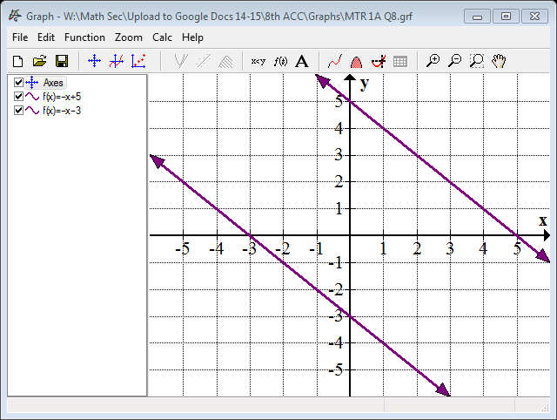In the graph below $g(x$) is a transformation of the original function, $(x)$. Identify the transformation in terms of $f(x)$.
$$f(x)$$

$$g(x)$$

2. $f(x – 8)$ C. $8f(x )$
3. $f(x) - 8$ D. $f\left(x\right)+8$
4. What change could be made to the relation to make it a function?

-5

0

5

10

-2

0

1

7

1. Replace $(0,0)$ with $(0,-2)$
2. Replace $(5,0)$ with $(3, 5)$
3. Replace $(10,7)$ with $(4,4)$
4. Replace $(10,1)$ with $(10,4)$
5. Marian borrows $\$400$ from her grandmother to purchase a new Ipad. Her grandmother asks Marian to pay her back at a rate of $\$8$ each week. Marian can determine the balance after *w* weeks she owes by using the expression $400 – 8w$. What does the constant $400$ represent?
6. The amount Marian will pay each week C. Amount borrowed
7. Monthly payment D. Interest on the loan
8. Analyze the graph of the function.



Domain:

Range:

Maximum:

Minimum:

Continuous or Discontinuous at

Zeros/Roots:

Increasing:

Decreasing:

Constant: