CC Alg I: Midyear Review Part 2A Name: _______________________

Cumulative Review for Semester 1 Date: _______________ Pd: _____

**II**. Student Produced Response. Follow the directions for each of the following.

1. Use the sequence: 5, 9, 13, 17,… to answer the problems below.
   1. Determine the recursive formula for the sequence. (Remember to define the first term.)
   2. Determine the arithmetic formula for the sequence.
   3. What is the 40th term in this sequence?
2. If $g\left(x\right)=x^{2}+2x-1$, determine $3\left(g\left(-4\right)-2\right)+1$.
3. Solve the following equation:
$$lculate the residual when st fit are shown below.2t-\left(8-2t\right)+6=4t-8$$

4. What is a solution for the following system of inequalities?
$$\left\{\begin{aligned}5x-y>4 \\ 2x+8y<-16\end{aligned}\right.$$

5. Using the data given, complete the following. Please round to the nearest hundredth.

Student Height in Period 1 (in inches)

55, 59, 60, 60, 60, 62, 62, 63, 64, 65, 65, 65, 65, 67, 68, 68, 68, 69, 70, 70, 70, 70, 72, 73, 74

1. Median: _______
2. Mean: ________
3. Mode: ________
4. IQR: __________
5. Range: _________
6. σ(x): __________
7. A scatter plot and line of best fit are shown below.

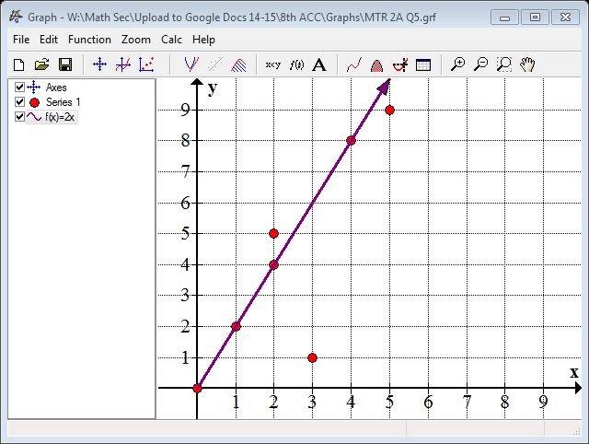

Calculate the residual when $x=3$.

1. Using the histogram given, determine the median test score. Round to the nearest hundredth of a percent.
2. Use the table below to answer the following. Round your answer to the nearest percent.

|  |  |  |  |  |
| --- | --- | --- | --- | --- |
| **Favorite Type of Music** | | | | |
|  | Pop | Country | Other | Total |
| Adults | 4 | 8 | 8 | 20 |
| Adolescents | 10 | 1 | 9 | 20 |
| Children | 3 | 3 | 4 | 10 |
| Total | 17 | 12 | 21 | 50 |

* 1. What is the joint relative frequency that the person surveyed was an adult who prefers country music?
  2. What is the marginal relative frequency that the individual surveyed preferred another genre of music?
  3. What is the conditional relative frequency of an adolescent, given that they prefer pop music?

1. Convert the following:
   1. 32 miles to inches
   2. 4 miles per hour to feet per second

**III**. Extended Constructed Response. Please answer each question fully. The points for each question are listed beside the problem.

|  |  |
| --- | --- |
| $$x$$ | $$D(x)$$ |
| 0 | 0 |
| 1 | 6 |
| 2 | 12 |
| 2.5 | 15 |

1. Two friends go jogging on the Appalachian Trail. They leave at the same time but do not wait for each other. Each travels at a constant speed until they reach their campsite, which is 30 miles away. Suzanne travels at 4 miles per hour, and is represented by the function S(x) = 4x. Dewey’s trip is represented in the table below where $x$ represents hours and $D(x)$ is total distance (in miles).
   1. Are both functions linear? Justify your answer.
   2. Identify the slope of both functions. What does the slope mean in the context of the problem?
   3. Describe the x and y intercepts of the functions in the context of the problem.
   4. The campsite was moved to 50 miles away. Dewey and Suzanne do not want to jog longer than 8 hours in one day. Will they be able to reach the new location? Justify your answer.
2. Mary Sue is planning to purchase a house this year. She found two communities that she would like to live in, Happy Hills or Amazing Acres. Suppose $y$ represents the total housing price (in thousands) and $x$ represent the number of years since 2010. In Happy Hills, the housing price can be represented by the equation $y=12.25x+210$. In Amazing Acres, the total housing price can be represented by the equation $y=14.75x+200$.
3. Graph each equation on the same grid below. Make sure to include labels/title.
4. In what year are the total housing prices the same? Justify your answer.
5. What does the domain and range of the functions in this situation represent? Explain.
6. In 2020, predict how much a house will cost in each community. With this information, if Mary Sue’s goal is the investment value, into which community should she buy? Justify your answer.